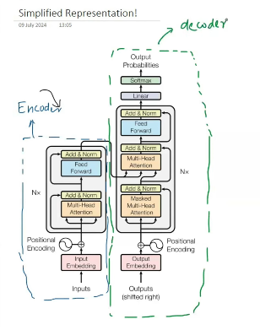
Nx – number of encoder blocks and decoder blocks.
In original paper, Nx=6.[ Encoder and decoder ], this is obtained by experimentations.

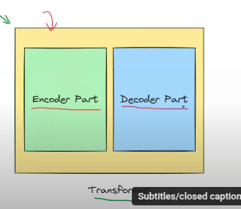
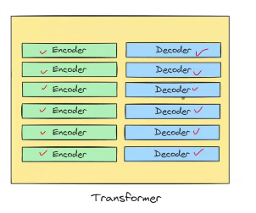
All the blocks inside the encoder are similiar to each other and same for decoder.
So understand one encoder block will make us understand every blocks of the transformer.

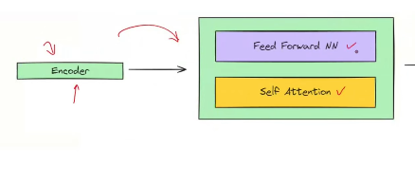
Each encoder block has:
- Self attention NN.
- Feed Forward NN.

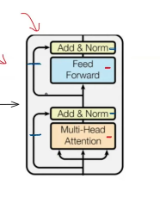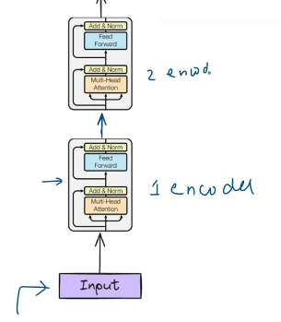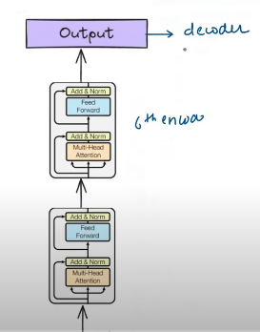
Input(sentence) is taken from user and it is passed through many different encoder layers. Started from encoder 1 to encoder 6.

Each encoder’s output is input to the next encoder. But the 6th encoder’s output is input the decoder.

How encoder works?

Input Layer:

- We pass the input sentence in the form of the batches.
- 3 steps:
  - Tokenization – breaking down the high level to the low level things. In this we divide the sentence into words.
  - Embeding: For every word tokenized is passed through the embeding layer to get the 512 dimensional vector.
  - Positional-Encoding: For each positional it will generate the positional encoding which is equal to the input dimension. 512 dimension.
    - Add( Xi ): Finally the embeding vector(step2) + positional encoding vector. (step3)
    - Xi = step 2 + Step 3, i represent all the word.
- This Xi is passed to the encoder layer.
- 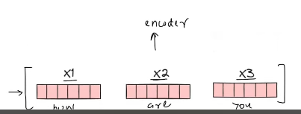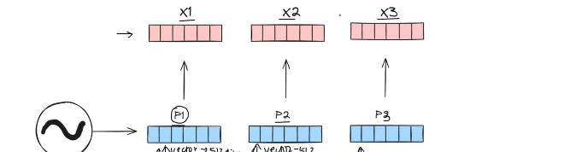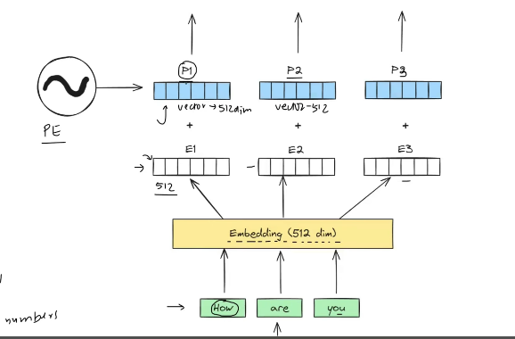
This is about Input layer.

First encoding block:
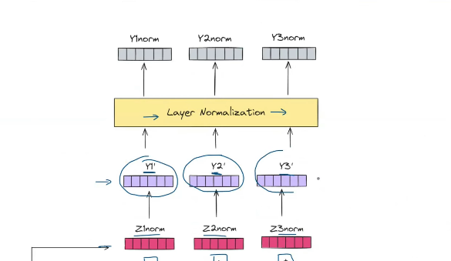

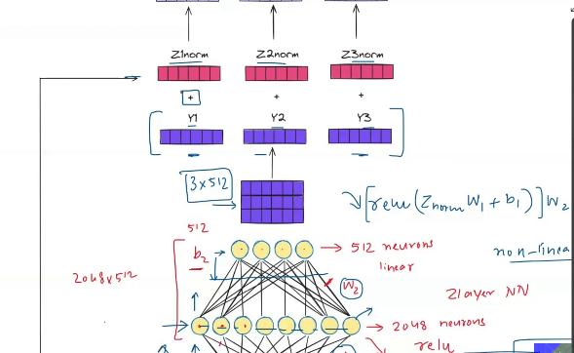

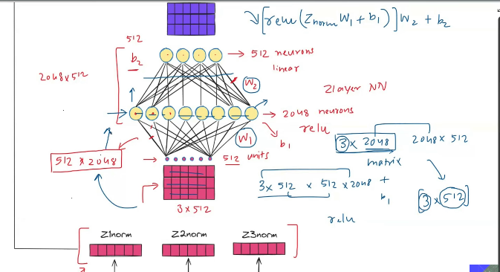
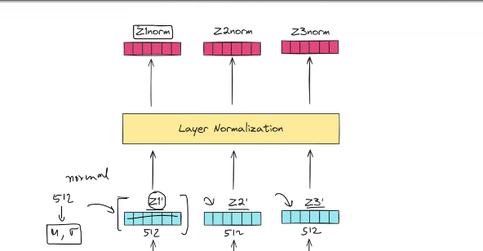

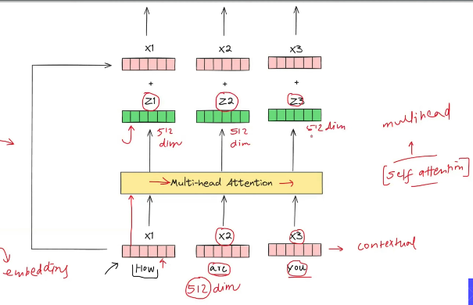

Add: Output from the multi head attention + Positional encoding.
Normalize: Stabilise the training process. Nueral network training is stabilised only when the input is in form.

The above result is passed on to the encoder end.

Non-linearity:
- Introducing more number of the nuerons, through which the add and norm result is passed.
- Initially 2048, then 512 as the nueral network.
- This is deep nueral network. With relu, introducing the non linearity.

Output from the previous Add Norm, and output of feed forward neural network.

Finnally the output is passed on to the next encoder.

The above is passed on to the next 6 encoders. The parameters size are different but the number of parameters remains same.

After the 6th encoder the output is passed oto the decodr.
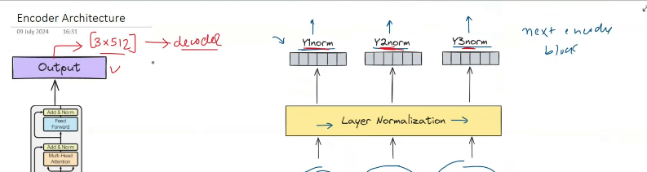

- Why residual connection?
  - Stable training in deep networks, gradient flow has alternate path.
  - If something useless occurs in between, Ex: if the multi-head attention do not perform well then then there is chances of making worst performance. So bypassing we focus at least on the original features.

  - Story:
    - A kaggle notebook, who developed the nueral netwrok from the scratch.
    - He forgot to add the residual connection , output getting generated was not that great.
    - But after adding the residual connection, the output was produced properly.

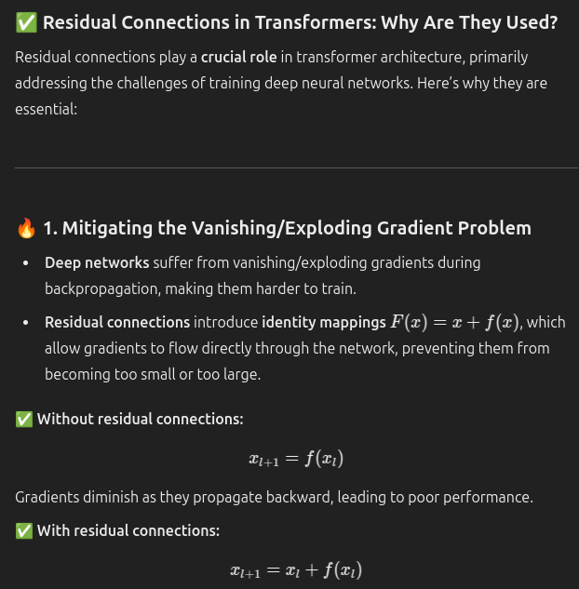
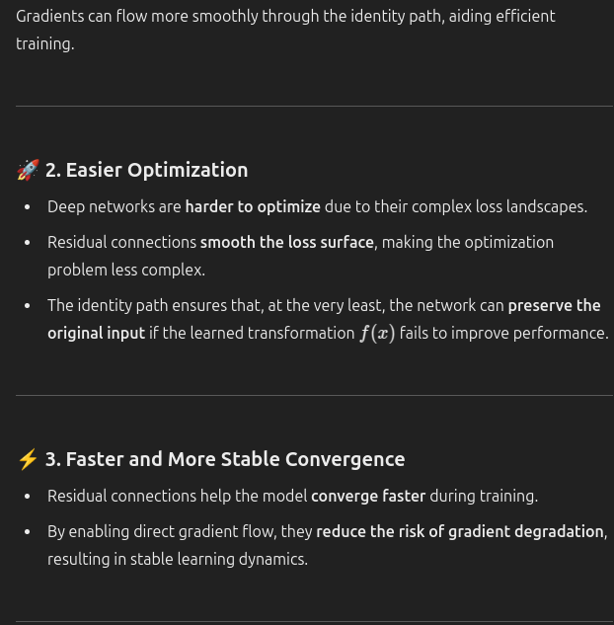
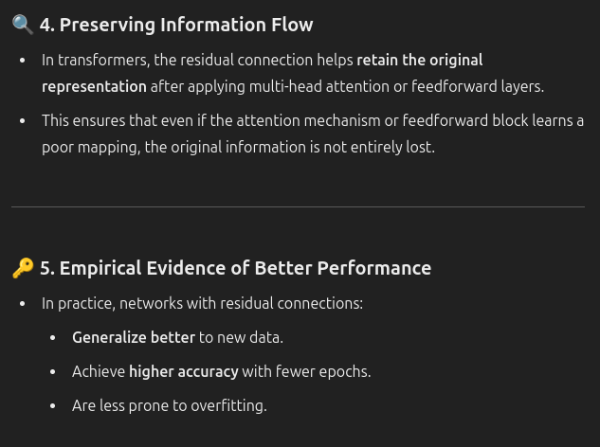
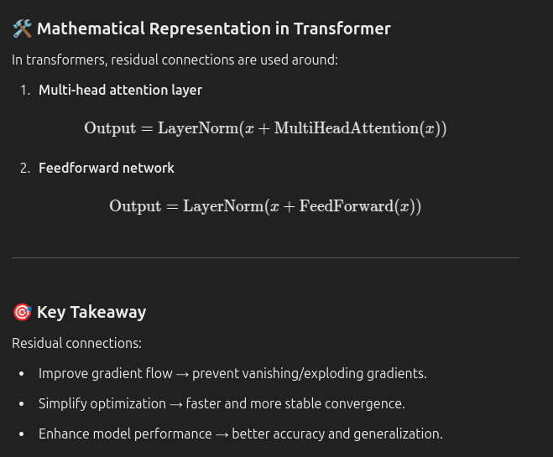

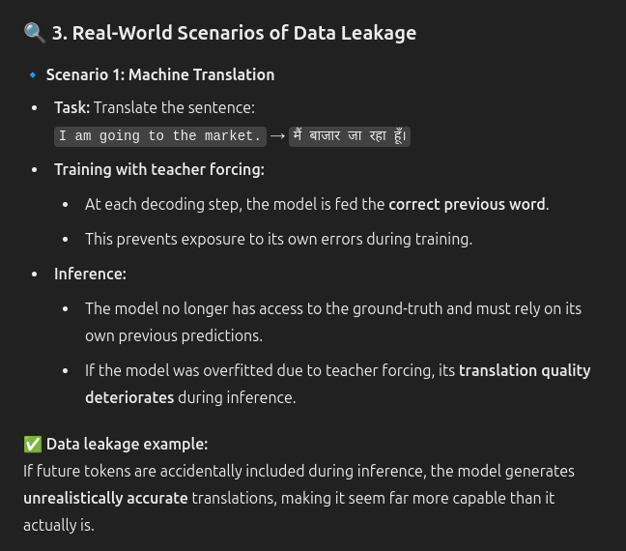
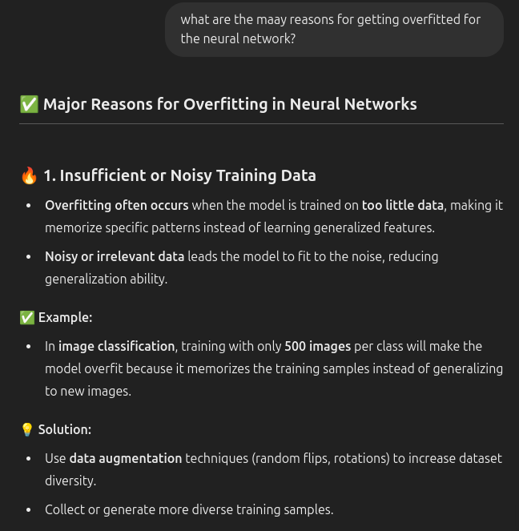

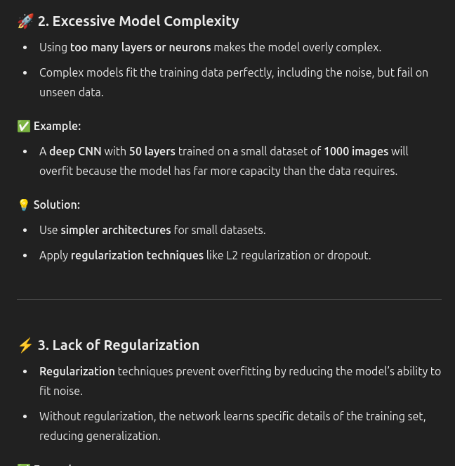
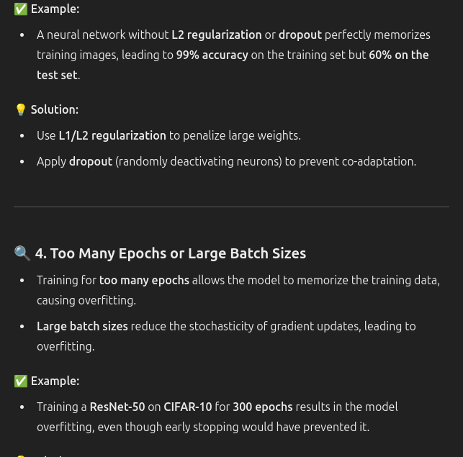
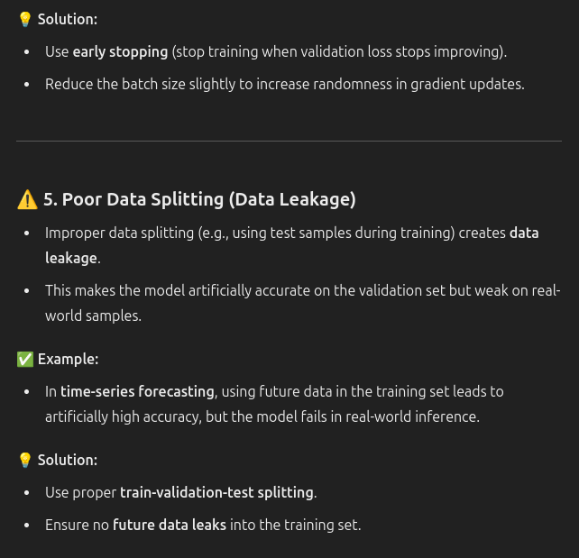

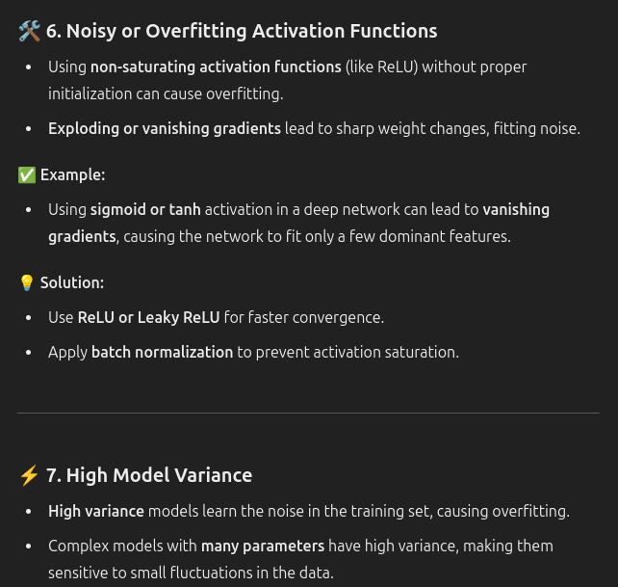

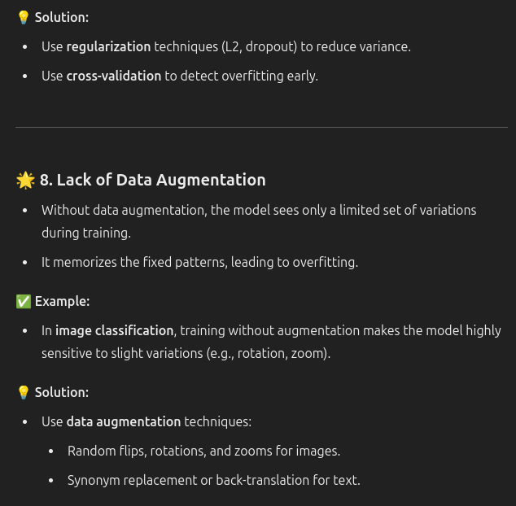
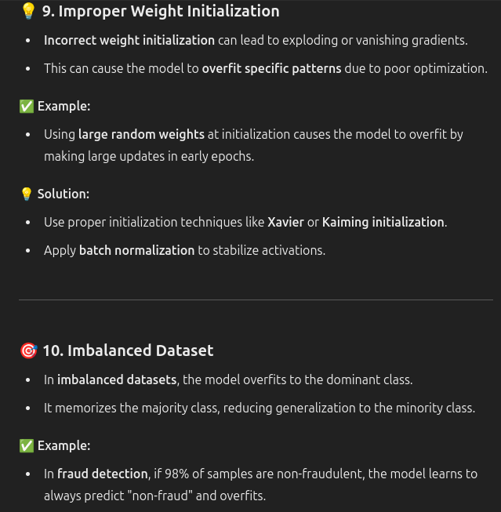

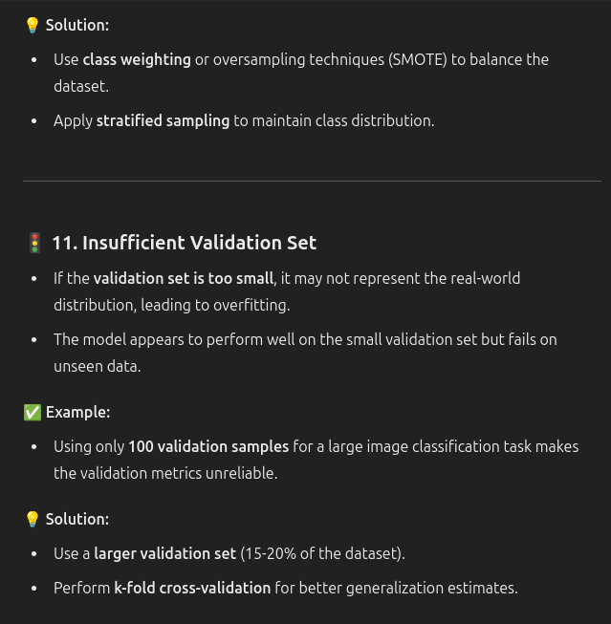

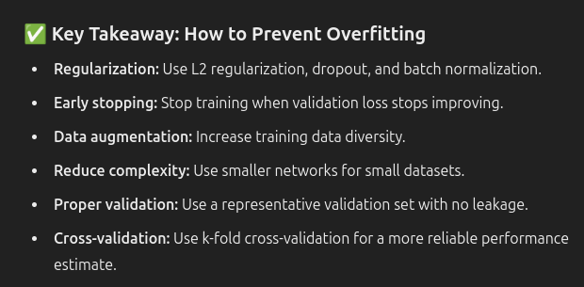

- Why use a FFNN?
  - Captures the non-linear complexity. Hence we use the relu. This is the idea.
  - 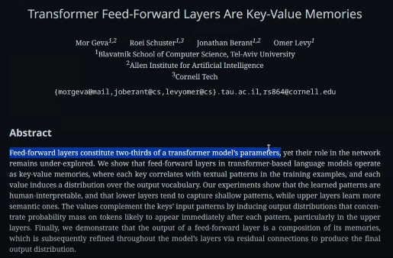

- Why use 6 encoder blocks?
  - Human language is usually heavy complex. To understand the complexity, we need to introduce strong representation.
  - To create a new deep learning.

Masked Multi Head attention

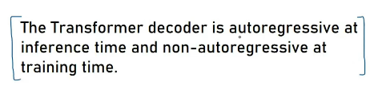
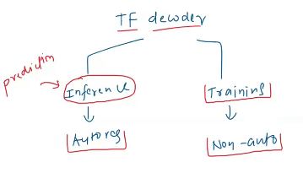
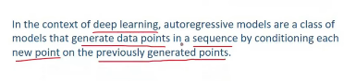
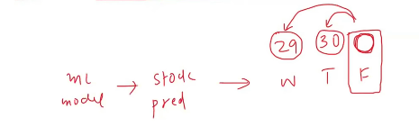
At training time, the current input at the decoder depends on the previous outputs of the decoder, hence called auto-regressive.
At testing time inference, we just pass the inputs to get the output at the decoder.
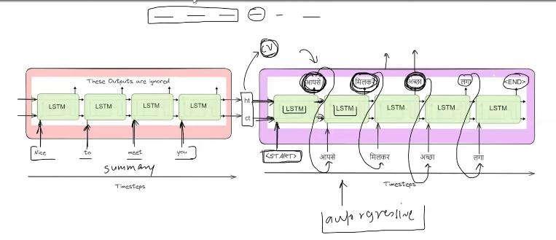
In these kind of architectures we cannot get the output paralley at the decoder side, the current input is dependent on the previous output.

Why this auto-regressive behaviour is seen?
Ans: Masked self attention.
Just for the time sake, Let me take it as , auto regressive nature at both the inference and training time.

Trained on :
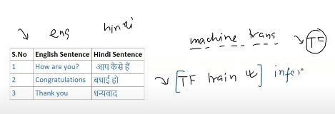

Inference:
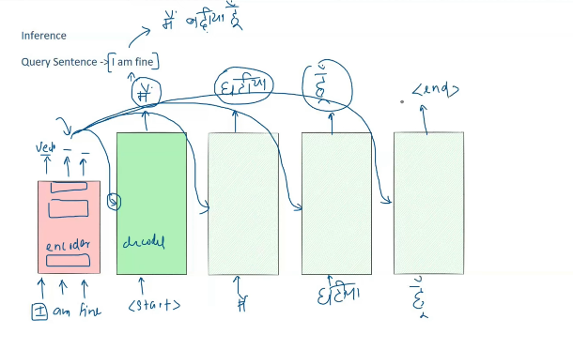
Inference output depends on the previous output from the decoder, hence it is auto regressive.

Training
Teacher forcing: Output generated at the previous stage of the decoder does not matter. The actual output required is passed on to make the training properly.
So even the output from the decoder at the previous step is wrong does not matter. At the next stage, teacher forcing is involved.
So original sequenced is passed on as the input to the decoder to get the output.

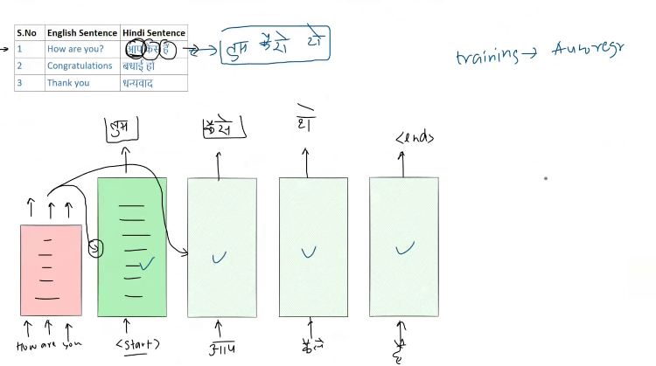

The output from the previous step is not passed on as the input to the decoder. It is the correct data’s output. Teacher forcing involved, hence it is not auto regressive.
Training is too slow , if the output needed is n words, we will be getting the n+1 outputs.

If we train the decoder in this format, it conusmes too much of time, since there is no dependency/compulsion/majboori, that the current output depends on the previous output steps of teh decoder. We can train decoder in parallely.

So we can execute parallely. This is ho training happens. Hence the training is fast.
But this parallel training is not so easy.

Masked Self attention

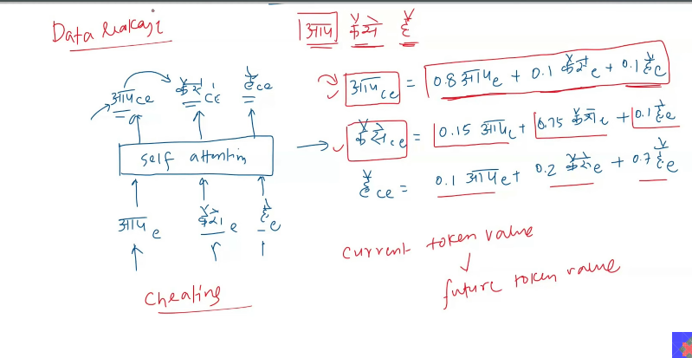
This is possible only when we are training , since all the vectors which are required to make the context embedding equation, all those vectors are available. Parallely at the training.

At inference, these all things are not available actually, when it comes to make the inference. So it has to take everything in auto regressive manner, that is the current depends on the previous.

Data Leakage: In transformers, data leakage occurs when the current token has access to future tokens during training or inference, which leads to unrealistic and over-optimistic performance.

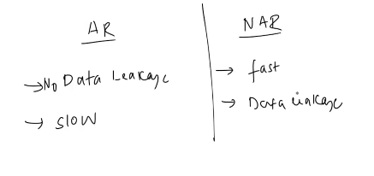
The above problem can be used in self attention.
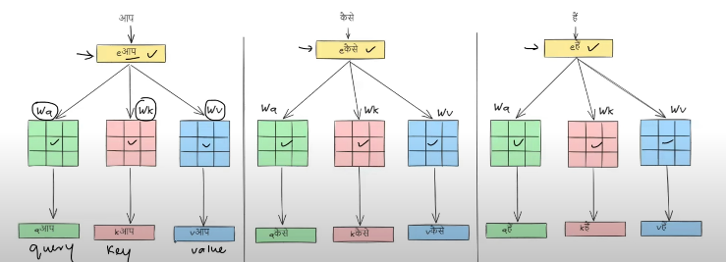

Query * key will give you a matrix which has the attention scores in it.
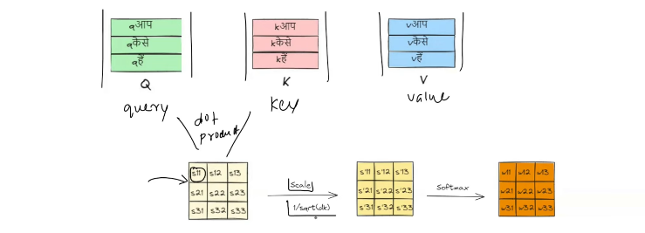

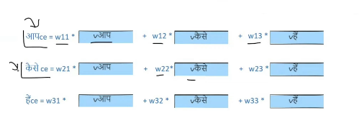
This is how the self attention works.

But in masked attention we do not need anything mentioned in the below red mark, so that w can overcome data leakage.
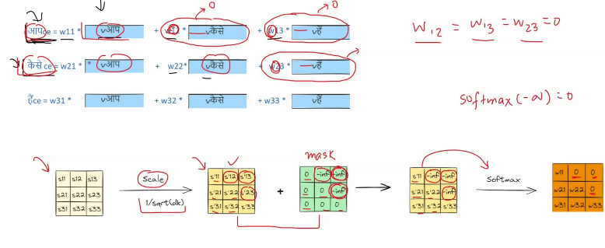
After Q^t * v, we got the new matrix(attention),
which is passed on for scaling

Mask: During this time, and new value is added, that is negative infinity.to which the attention came out.
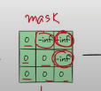

Finally
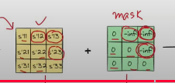

To nullify their effect. So called mask Then this is passed on through the softmax.
The softmax resultant is 0.
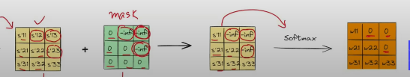
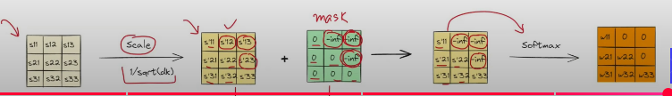

Resulatnt would be like making those weights equal to zero.
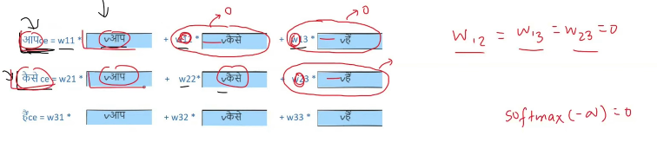
This is the way we made non auto regressive made, in inference.

CROSS ATTENTION
[IMPORTANT]

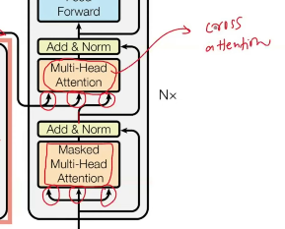

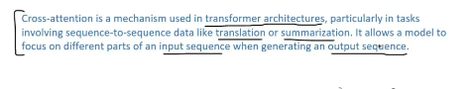
The next word depends on:
- What has been generated till now?
  - Can be extracted using self attention.
- What is the input sentence from the encoder at decoder to be given the higher importance?
  - 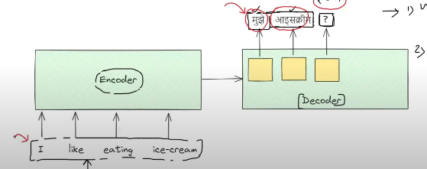
  - Neded:
    - 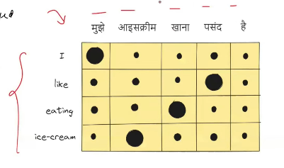
    - Cross attention: The mechanism that is used in order to generate the above matrix , what is the relation between the input and output, is called cross attention.

    - Cross attention: It speaks about the contribution to the output from the input sequence. 
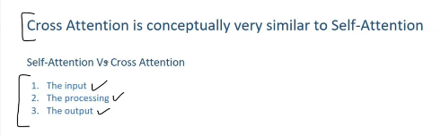

Self attention:
- Input :
  - The sequence’s contextual embedding from the previous layer is passed on to the next layer.
- Processing:
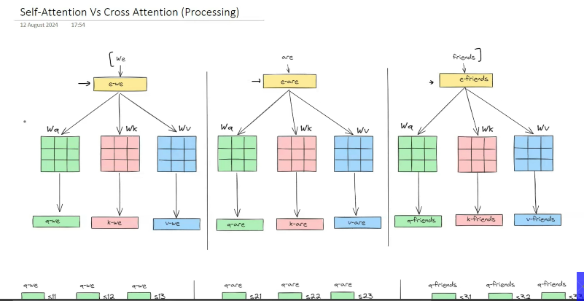
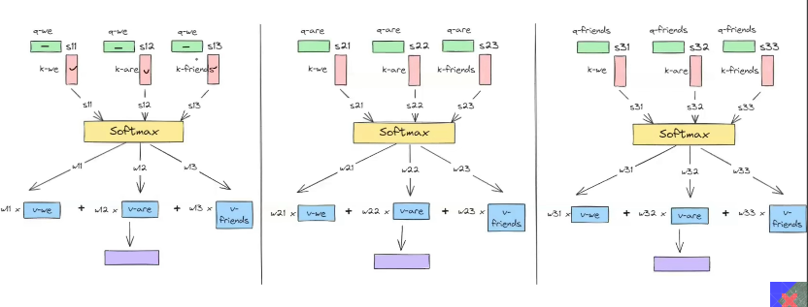
The blue is the contextual embeding.

3. Output :
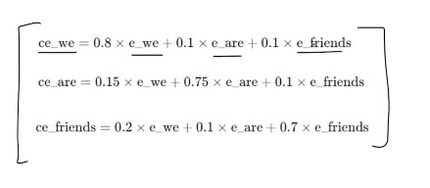
This is just representation not exactly, how it works.

Cross attention:
- Input:
  - Contextual embedding of the sentence.
  - Contextual embedding of the output is taken and given as input.
- Processing:
  - Query: Comes from the hindi word.
  - Key and value comes from the english word.

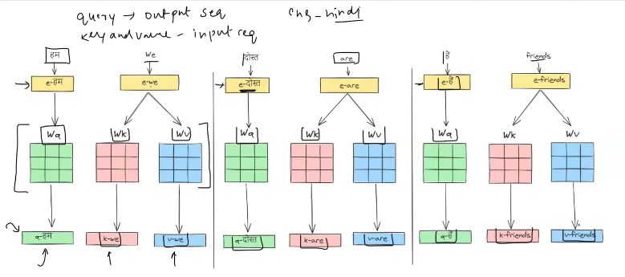
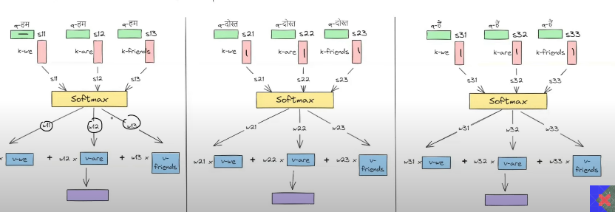
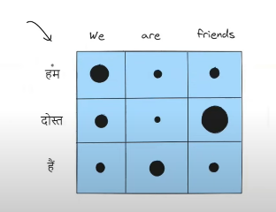
The black mark representing the above is the weight matrix , obtained after applying the softmax function.

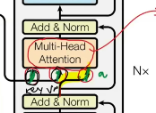

The key and the value comes from the encoder’s output. Query comes from the decoder’s part previous output .

3. Output:
- The number of output context vector depends on the output to come as the output.
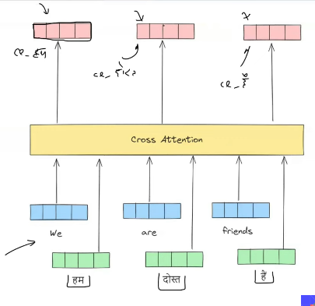
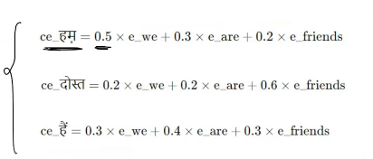
This is just the representation.
The output sequence vector completely depends on the input of encoder sequence.

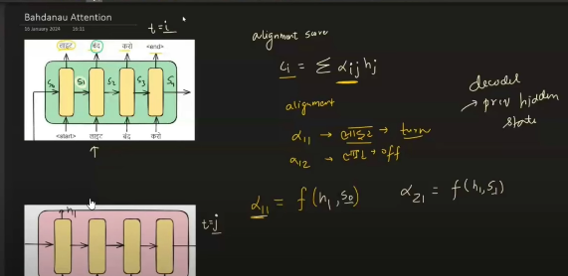
This cross attention, has the motivation from the bahdanau/Luong attention.
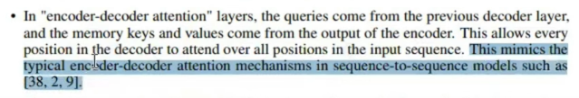

Use Cases of the Cross Attention:
- Image caption,
- text to image genaretion.
- Text to speeech.

TRANSFORMER DECODER

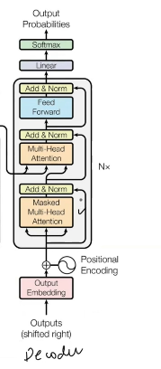
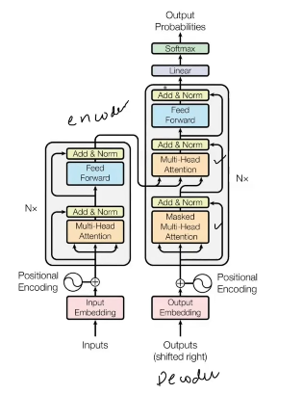

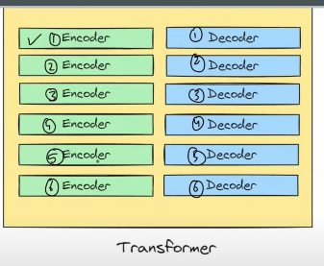
It is more like , from a company the generated mobiles remains same, the apps within the mobile may vary.
Like that the encoder architecture remains same, but the parameter value inside the encoder changes.

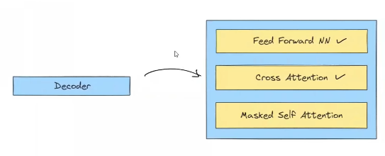
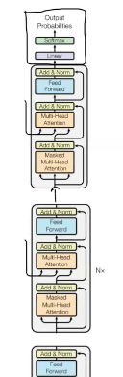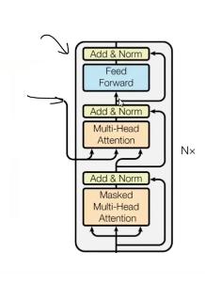

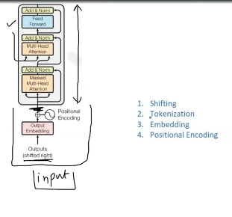

Input to the decoder, what happens here?
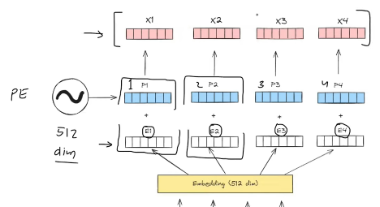
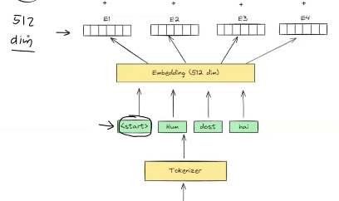
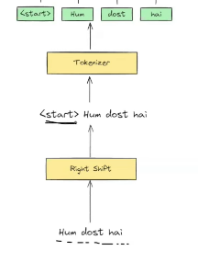

What happens inside the decoder block?
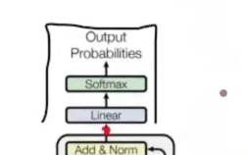
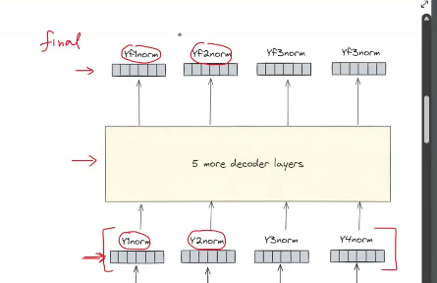
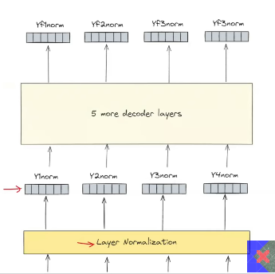
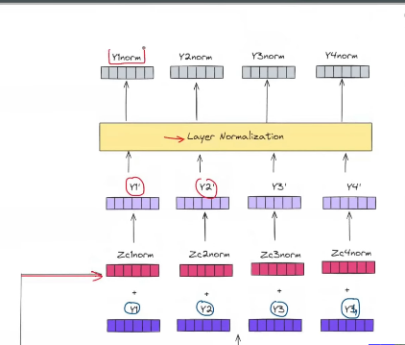
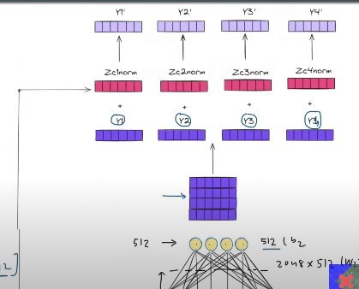
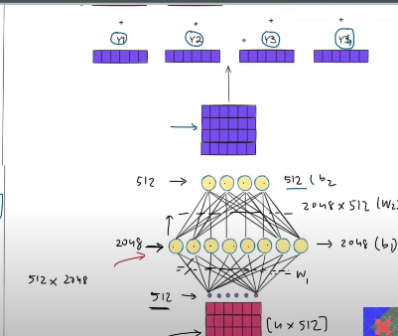
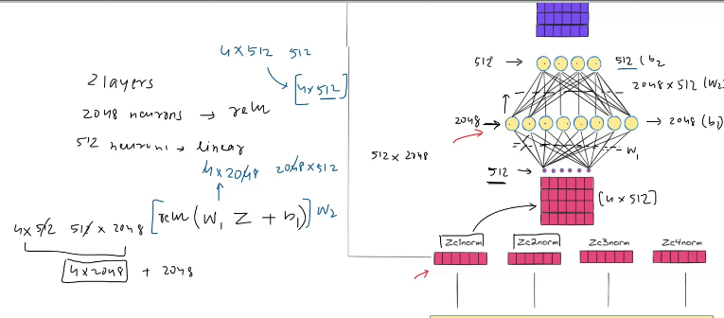
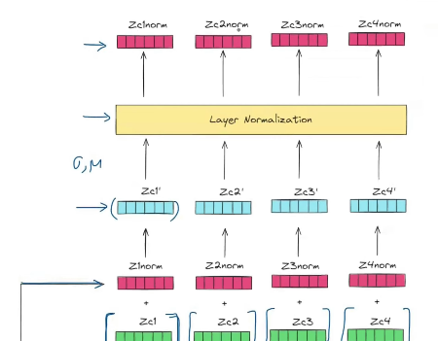
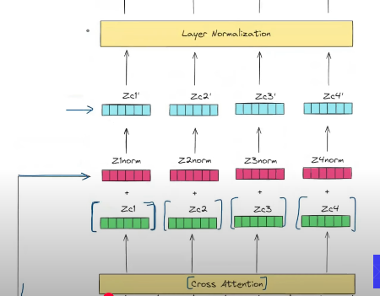
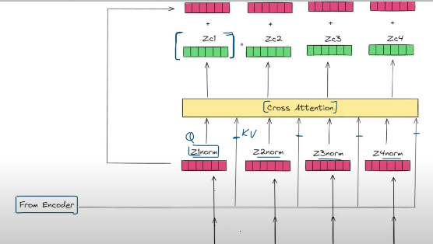
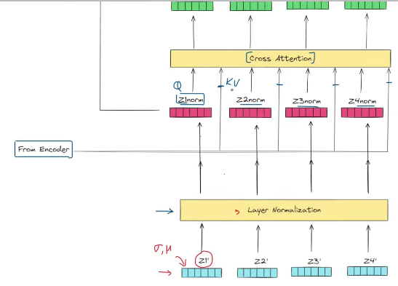
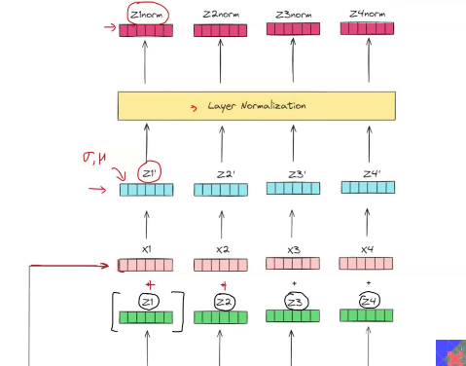
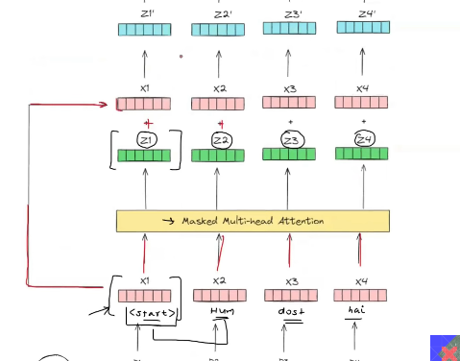
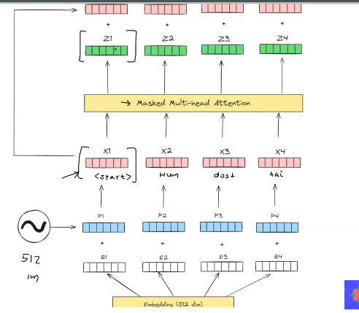

Masked attention:

To generate the z1, we consider only the x1.
To generate the z2, x1, x2 both are considered.
To generate the z3, x1,x2,x3 all are considered.
This is the difference between the masked self attention and normal self attention.

Add the x1,x2,x3 the original with the masked multi head attention. Hence Residual connection is used.

Cross attention is applied Now.

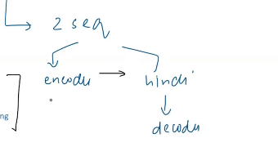

Output block of Decoder

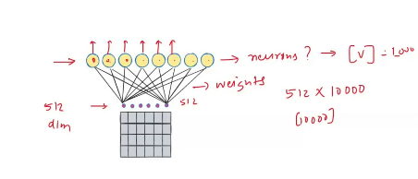
V decides what is the number of different unique words in the vocabulary.
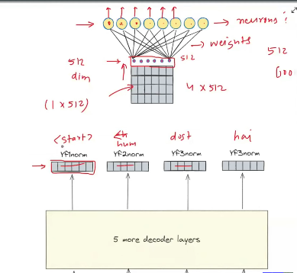
From the input we get the corresponding number of output context vectors.
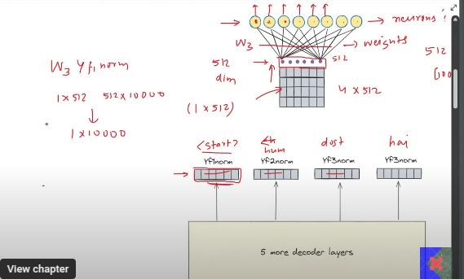

There will be many outputs from the decoder which is the context vector.
Unnormaised vector:
For each and every vector there will 10k output which represents the probability of each and every word. Which is not normaisd

Softmax:
Which is passed on through the softmax, hence the normalised vector will be produced, hence the summation would be 1.

By using that we will be producing the output one after the other.

TRANSFORMER INFERENCE

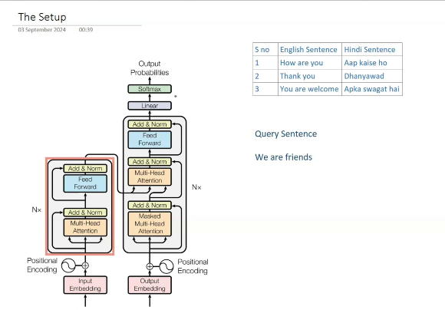
There will be more than a lakh number of records.

The encoder behaves the same during inference and training.
Feed forward is introduced in order to capture the nin linear behavior.
Context vector for each and every input word. This vector is passed on to the decoder architecture.

Decoder changes its behavior, during training vs inference.
Training - Non auto regressive.
Inference - auto regressive.
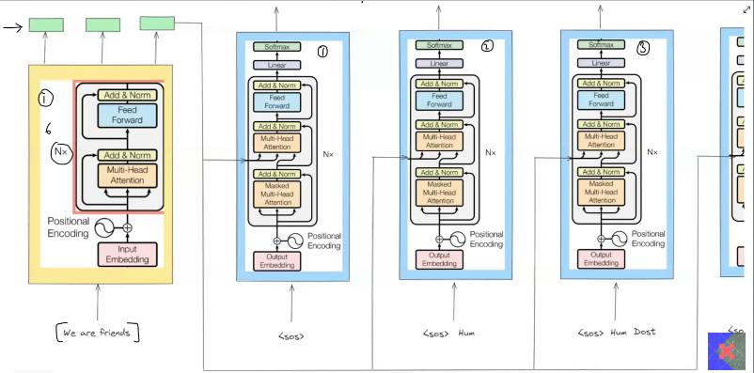
To start the process at the decoder we are going to pass the special token .<SOS>

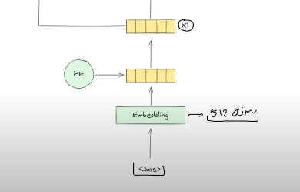
After adding the word embeding with the positional encoding, this will be passed to the decoder.

In decoder we have:
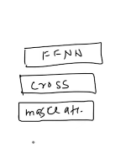
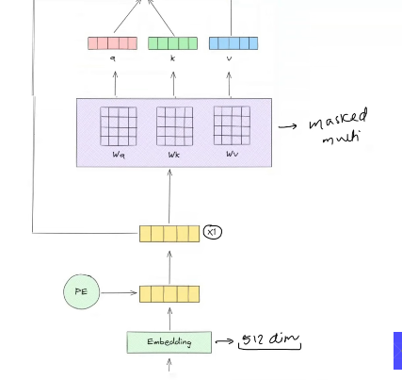

X1 will be mutlipled with the Wq, Wk, Wv vectors, then this will produce the Q,K,V vectors.

Then Q^T * K, is made to get the attention score. This is scaled, then this is multiplied with the Value vector.

The output v from the number of the
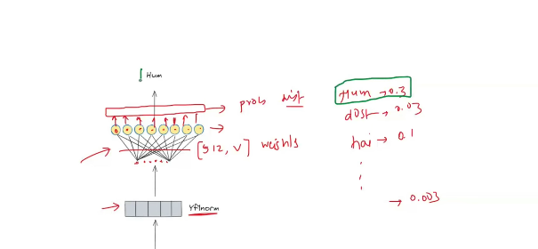
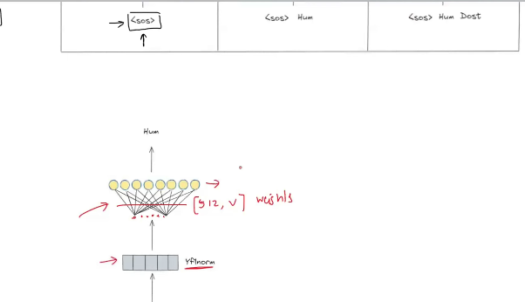

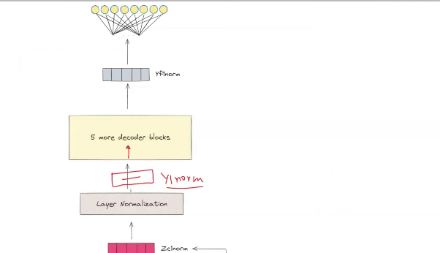

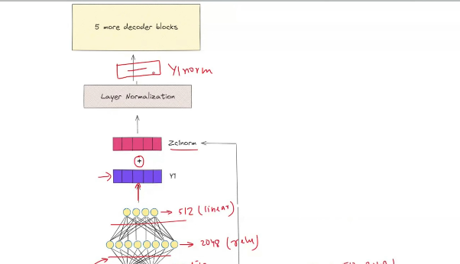
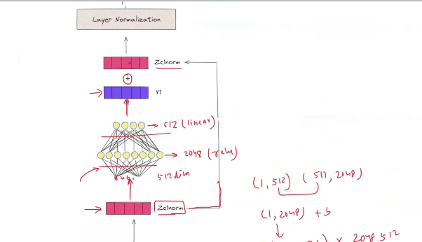
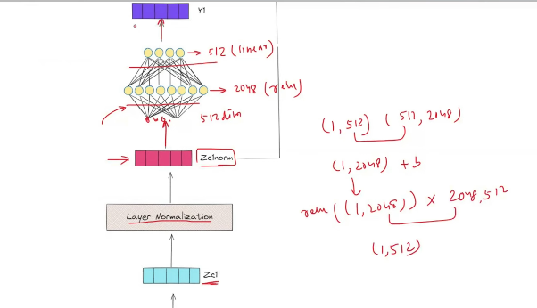
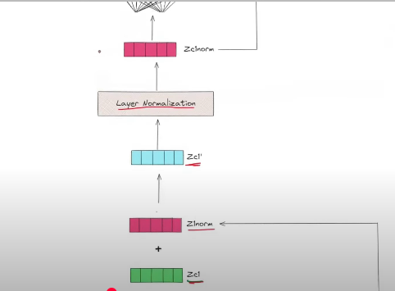
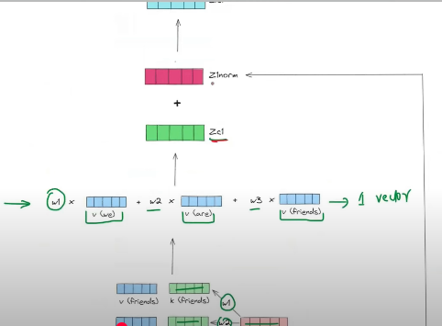

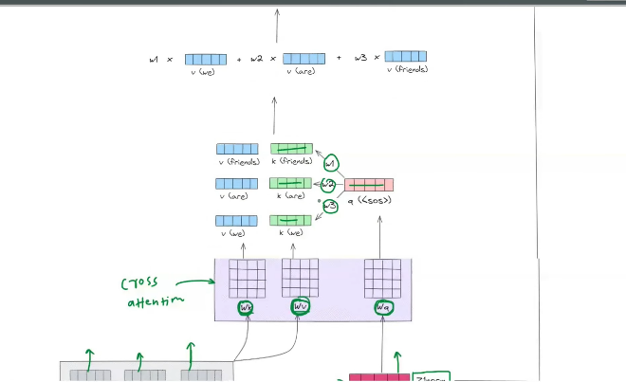

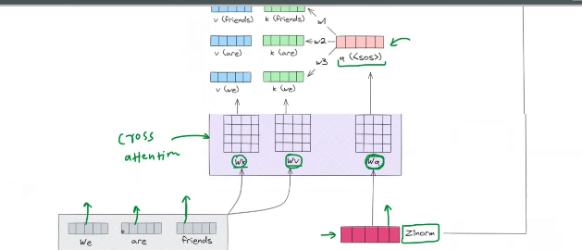

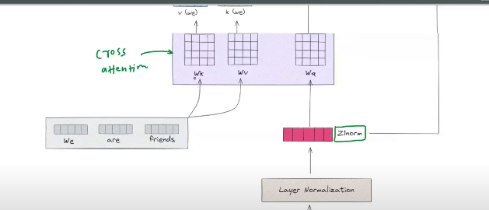

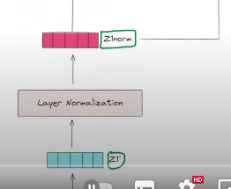
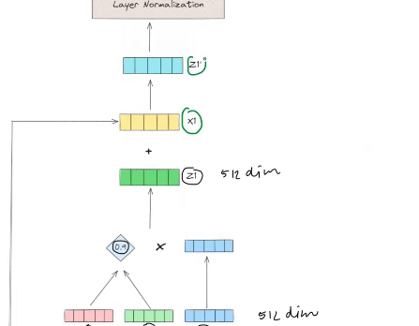
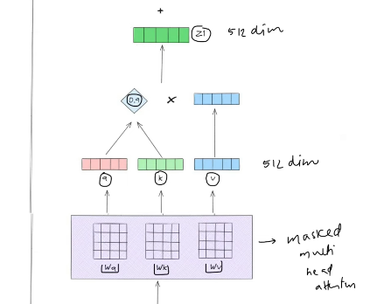

You will get the Q,K,V of each and every word, when multiplied with the corresposponding wk,Wv, Wq.

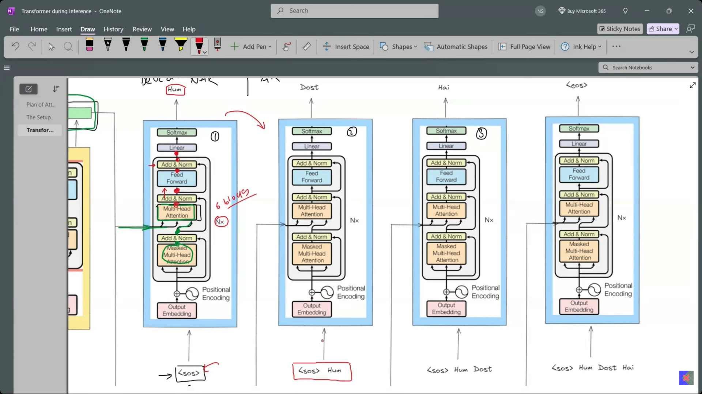

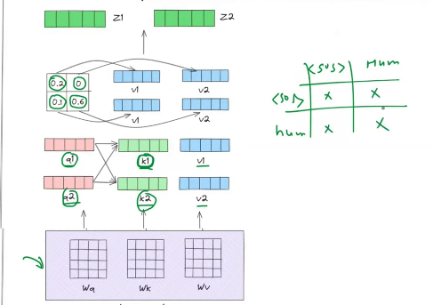
The matrix is produced by making the dot product, (q*k), which is nothing but the the matrix.
After making the cross product matrix, we make use of the masking.

Masking matters during inference:
- If we are not masking, then there will be data leakage.
- If not used, there will be shift in data, so prediction will not be good.
- 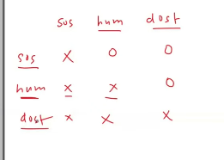

Very very important, till the end point we are going to take the all the vector, but at the end we will be taking only the last one to predict the output.

Then in next time, we will be sending the 3 vector

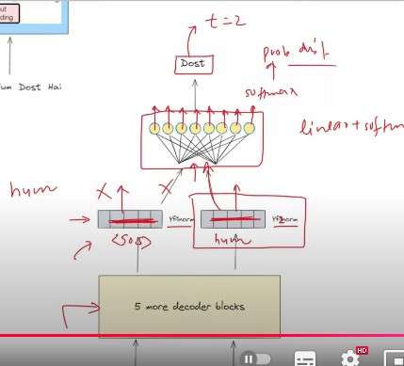
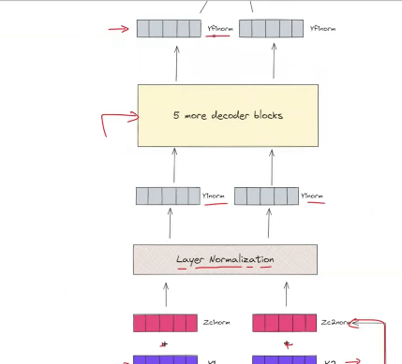
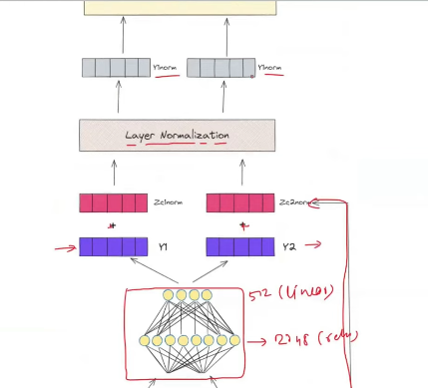
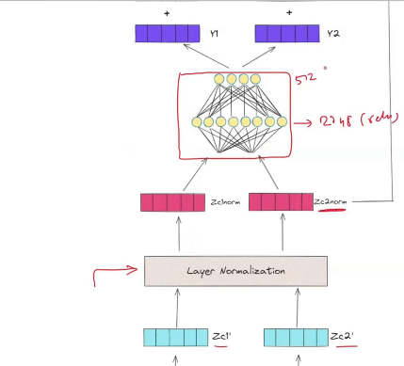
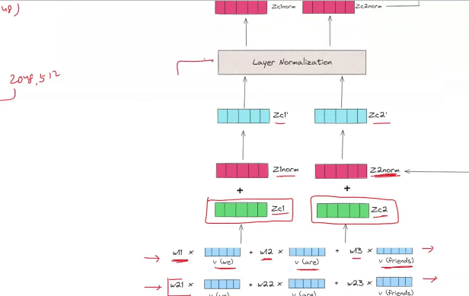
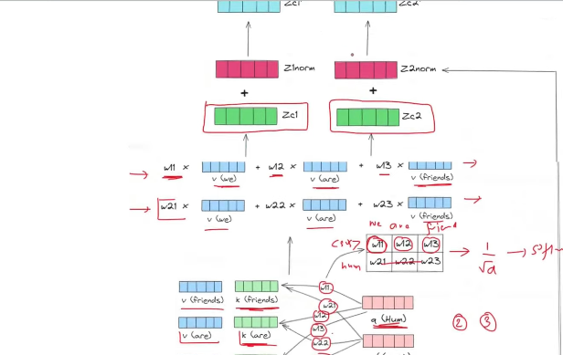

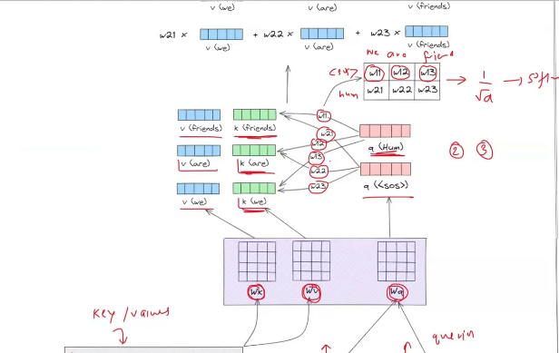

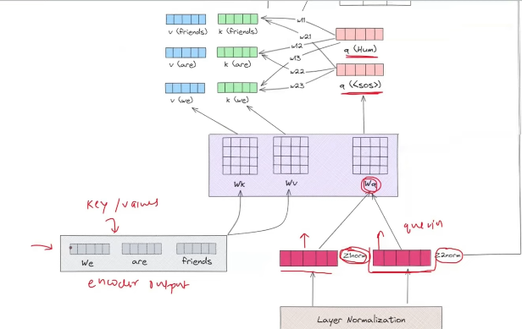
- 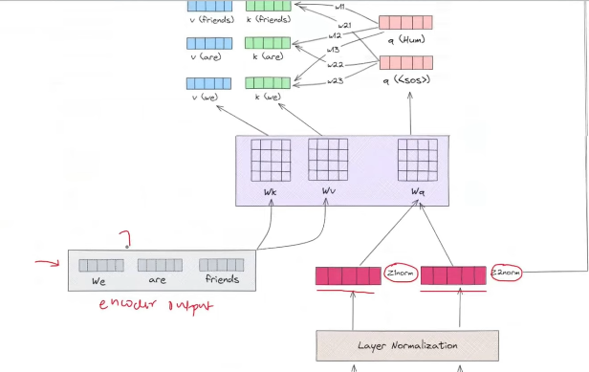
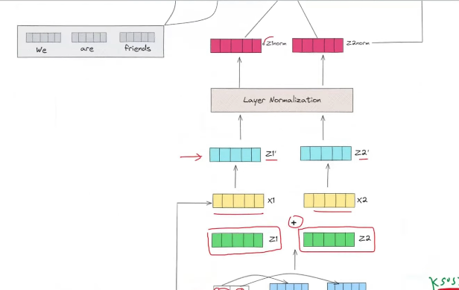
- 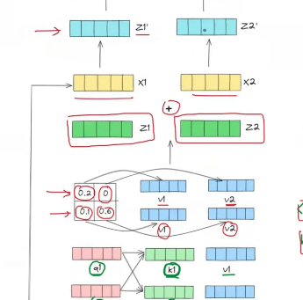
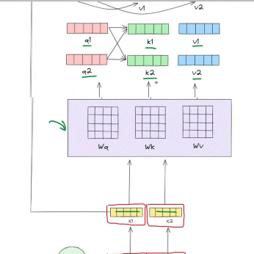
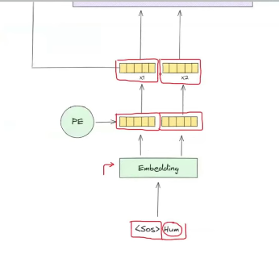

Then in next time, we will be sending the 3 vector as input.
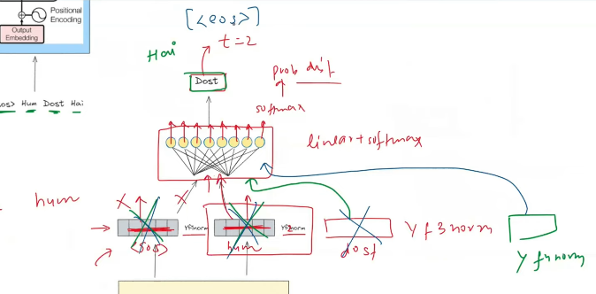
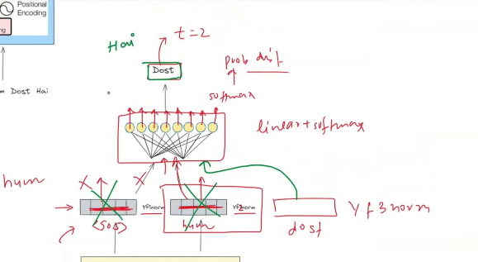
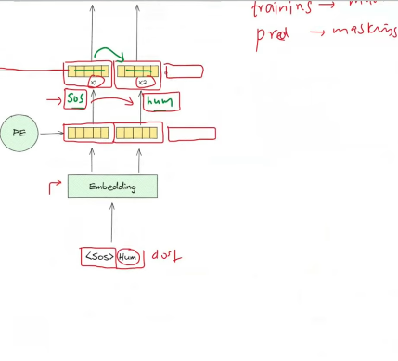

This is how transformer works in inference time.
For each and every time, the number of tokens to be passed to the transformer will change.
Masking will be there in training and inference time .
Decoder behaviour during training will be more like non auto regressive. During inference, it behaves like autoregressive.

